ORDER AND ORDER DETAILS MANAGEMENT SYSTEM
PURPLLE ONLINE BEAUTY SHOPPING

- INTRODUCTION

The Purplle Online Beauty Shopping Database Management System is designed to manage customer orders and order details. The Orders and Order_Details tables store order information such as order date, quantity, price, and total amount.

- OBJECTIVES
- Design Orders and Order_Details tables.
- Manage customer product orders.
- Store order date, quantity, and total amount.
- Perform order insertion and modification.
- Generate customer order history reports.
- Generate customer-wise order summaries.
- DATABASE DESIGN

3.1 ORDERS TABLE
Attribute | Data Type | Key | Description
Order_ID | INT | PK | Unique order ID
Customer_ID | INT | FK | References Customer
Coupon_ID | INT | FK | References Coupon, if applied
Order_Date | DATE | - | Date of order
Total_Amount | DECIMAL(10,2) | - | Total order amount
Order_Status | VARCHAR(30) | - | Pending/Shipped/Delivered/Returned
  - ORDER DETAILS TABLE
Attribute | Data Type | Key | Description
Order_Detail_ID | INT | PK | Unique order detail ID
Order_ID | INT | FK | References Orders
Variant_ID | INT | FK | References Product_Variant
Seller_ID | INT | FK | References Seller fulfilling this line item
Quantity | INT | - | Ordered quantity
Unit_Price | DECIMAL(10,2) | - | Price per unit at time of order

- TABLE RELATIONSHIPS

CUSTOMER (1) ─────────── (M) ORDERS
│
│
▼
ORDER_DETAILS
(M) (M)
│ │
▼ ▼
PRODUCT_VARIANT SELLER

Customer_ID (PK) → Customer_ID (FK)

Order_ID (PK) → Order_ID (FK)

Variant_ID (PK) → Variant_ID (FK)

Seller_ID (PK) → Seller_ID (FK)

- TABLE CREATION

5.1 CREATE ORDERS TABLE

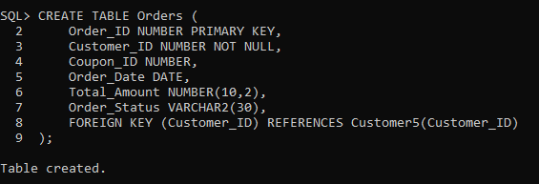

5.2 CREATE ORDER DETAILS

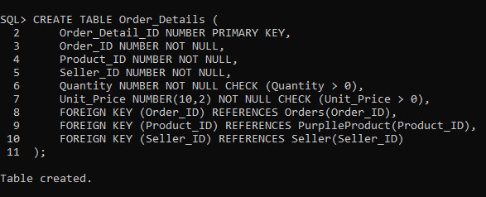

- ORDER DATA INSERTION

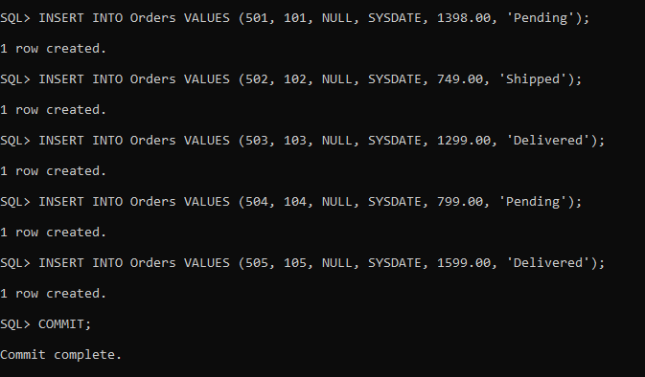

- ORDER DETAILS INSERTION

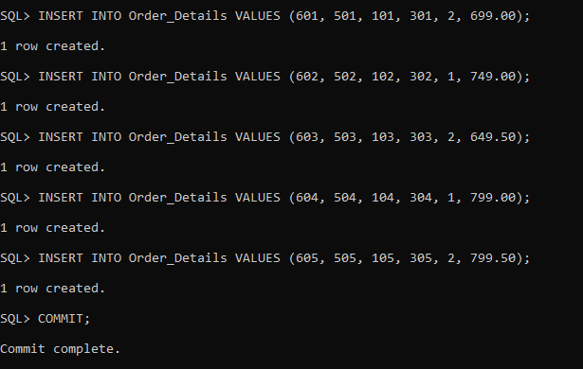

- DATA RETRIEVAL

8.1 DISPLAY ORDERS RECORDS

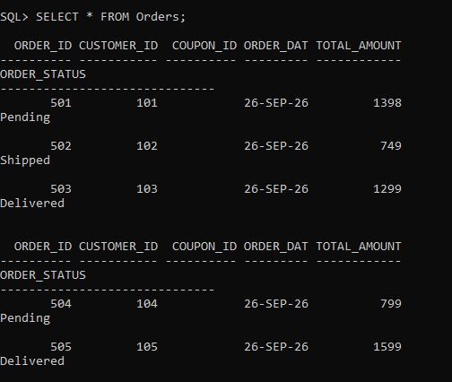

8.2 DISPLAY ORDER DETAILS RECORDS

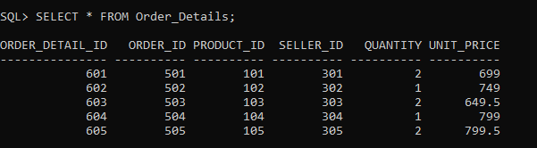

- ORDER MODIFICATION OPERATIONS

9.1 MODIFY ORDER AMOUNT

9.2 MODIFY ORDER DATE

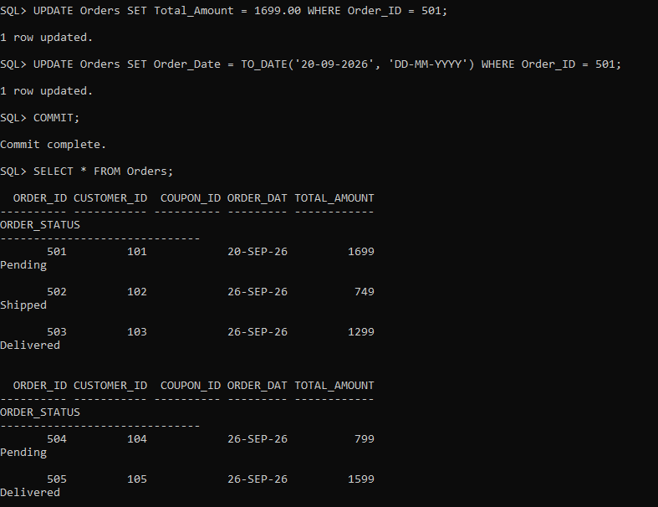

- ORDER DETAILS MODIFICATION

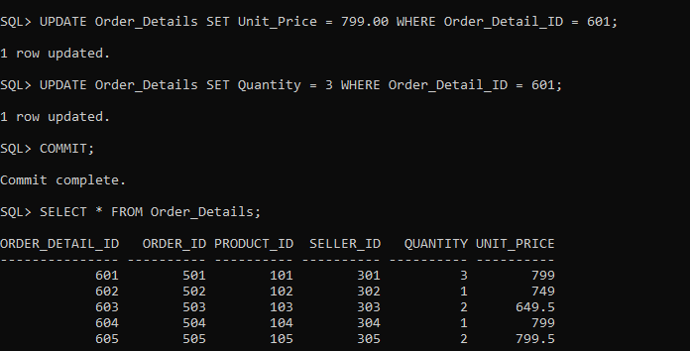

- CUSTOMER ORDER HISTORY REPORT

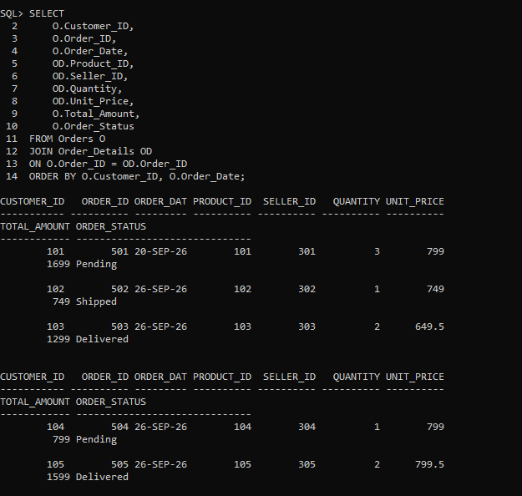

- CUSTOMER - WISE ORDER SUMMARY

